ASSIGNMENT 1

**(CS 6650 - Building Scalable Distributed Systems)**

**Running the application:**

The application is divided into 3 Parts:

* The Server
* The Client Part 1
* The Client Part 2

The server needs to be hosted and kept running either on Cloud (e.g AWS) or Localhost. The client will then need to modify the **resources/config.properties** to point to its address and execute calls.

A sample view of contents of config.properties looks like:

1. maximum number of threads to run (maxThreads - max 256)
2. number of skier to generate lift rides for (numSkiers - default 50000), This is effectively the skier’s ID (skierID)
3. number of ski lifts (numLifts - range 5-60, default 40)
4. the ski day number - default to 1
5. the resort name which is the resortID - default to “SilverMt”
6. IP/port address of the server

Config.properties

***cmd.maxThreads=32***

***cmd.numSkiers=50000***

***cmd.numLifts=60***

***cmd.skiDay=1***

***cmd.resortId=SilverMt***

***#Local***

***cmd.addressPort=http://localhost:8081/CS6650Assignment1Server_war_exploded***

To run the application, the client needs to be packaged as .jar with configured config.properties. Then run as below:

**Java -jar client_jar_name.jar**

# 

## The Server

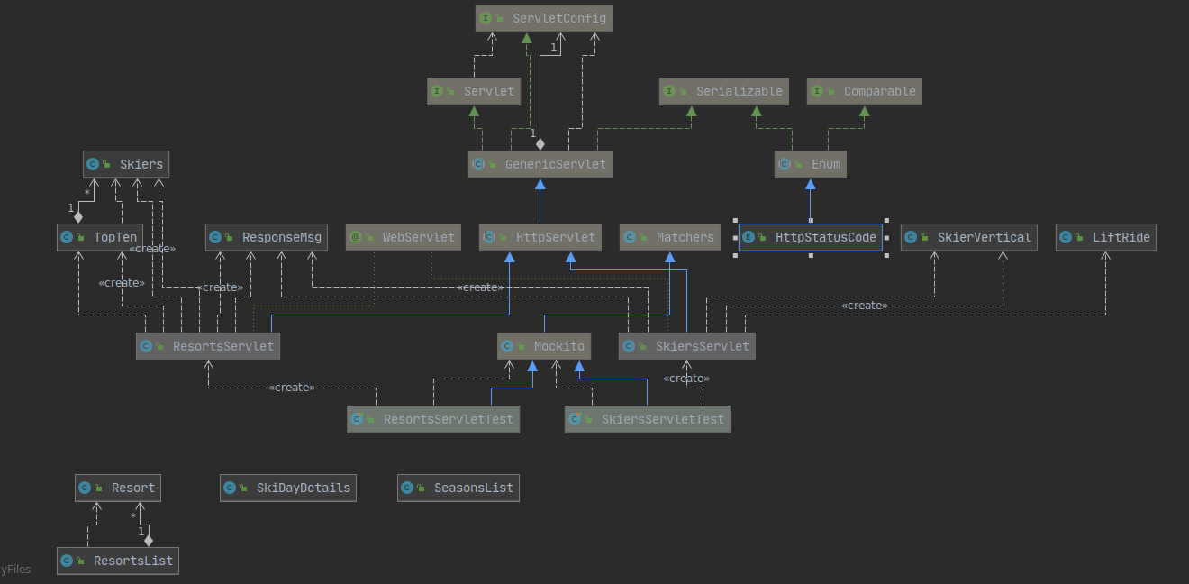

**The server exposes below API using Java Servlets:**

**resorts**

**GET/resort/day/top10vert**

**skiers**

**POST/skiers/liftrides**

**GET/skiers/{resortID}/days/{dayID}/skiers/{skierID}**

**GET/skiers/{skierID}/vertical**

## 

## The Client Part 1

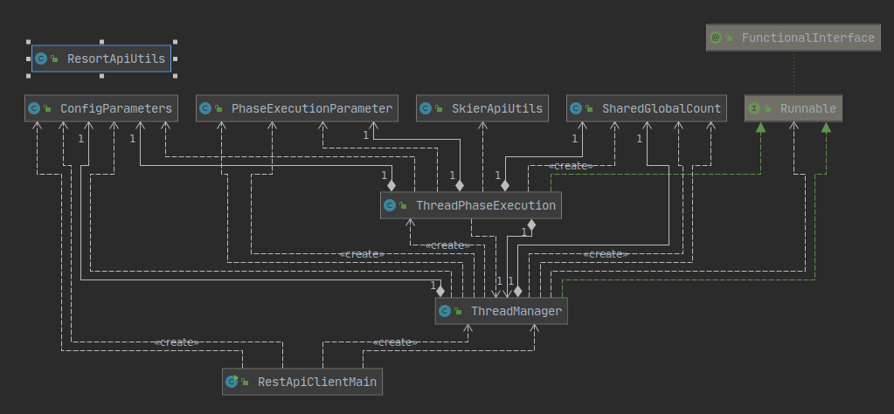

The Client has been designed as a multi threaded client. The client execution starts with execution of the jar file and clients main class *RestApiClientMain* is called. The main class parses the input config.properties into a properties file and initializes *ConfigParameters* class.

The control is then passed to *ThreadManager* class which is executed in a separate thread then main. The threadManager takes care of threads phase execution by calling *ThreadPhaseExectution* class with their respective configuration as initialized in *PhaseExecutionParameter* Class.

The respective phases are then executed and after 10% of each phase is elapsed the next phase is started,this is taken care of by using CountDownLatch and initializing it to 10% of the total number of threads for a respective previous phase.

The execution then terminates with results printed to the console. A sample output will look like:

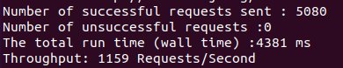

## The Client Part 2

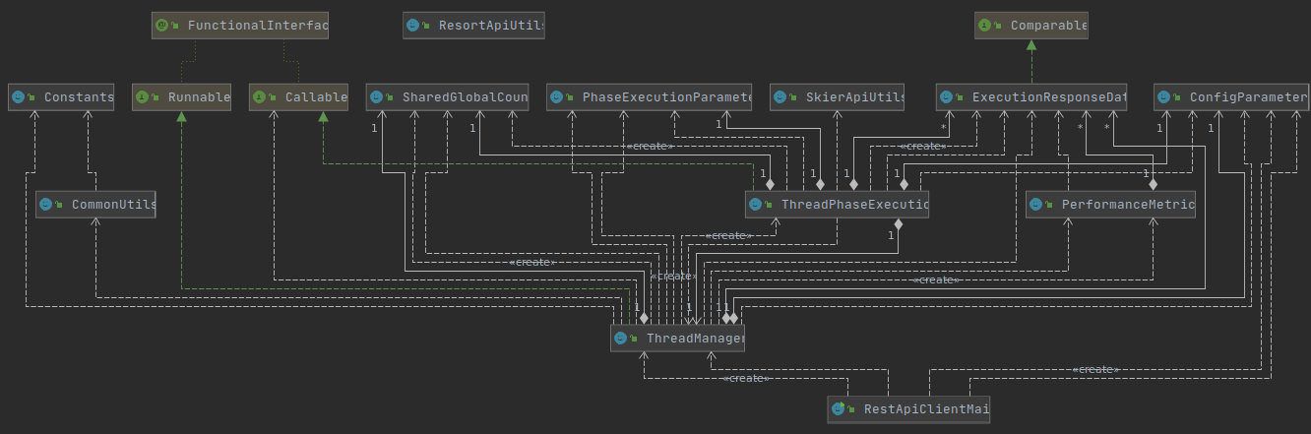

The Client has been designed as a multi threaded client. The client execution starts with execution of the jar file and clients main class *RestApiClientMain* is called. The main class parses the input config.properties into a properties file and initializes *ConfigParameters* class.

The control is then passed to *ThreadManager* class which is executed in a separate thread then main. The threadManager takes care of threads phase execution by calling *ThreadPhaseExectution* class with their respective configuration as initialized in *PhaseExecutionParameter* Class.

The respective phases are then executed and after 10% of each phase is elapsed the next phase is started,this is taken care of by using CountDownLatch and initializing it to 10% of the total number of threads for a respective previous phase. As results need to be returned for each executed thread, Callable is used instead of runnable as in client part 1. The results are stored in list of *ExecutionResponseData* class, this list is then passed to *PerformanceMetrics* class which takes care of generating mean, median and various other performance metrics.

The execution then terminates with results printed to the console and CSV is generated from run results as stored in List of *ExecutionResponseData* Class. A sample output will look like:

